Version 0.5

Team assignment 1 – Architecture the drivers.

- High level functionality.
ID | Name | Description
F01 | Customer management | Support user to add, edit or disable customer informantion. Calculate and store customer’s bonus point.
F02 | Sale management | Support user to make a payment, export and print invoicesto customer.
F03 | Commodity management | Support user to manage commodity, commodity categories, commodity quantity.
F04 | Price management | Support user to manage commodity price include standard price and retail price.
F05 | Synchronization | Support to synchronize data between clients and server.
F06 | Statistics and reports | Support to make statistics and reports in real time.
F07 | Shop management | Manage goods, group of goods and price in local shop.
F08 | System management | Manage cashier information in system

- Constraints.
Technical constraints.

ID | Name | Description
 | System | Both the head office server Database and the POS terminal Database can be accessed during the sales operation
 | System | The product codes can read with bar code readers of POS terminals or enter code by ussing computer keyboard
 | Network | Client – server, POS client and center server
 | Database | SQL server
 | Database | Server and client use local database for system.

Bussines constraints
ID | Name | Description
1 | The bonus point rate | is fixed, and stored in the system as constant
2 | Point are recorded in the system, and not on card | The awarded points can be used by the member who accrued the points in place of cash when making a purchase. Points can be used in all stores.
3 | The bonus points become valid for use the following day
4 | The number of points used is immediately subtracted from the number of points accrued by the member
5 | For each product, its standard price, common to all stores
6 | The system executes a batch process which post-processes the sales operations from previous day, and prepares for the daily sales operations.
7 | Develop within 6 weeks. | Constraint about schedule of project.
8 | Develop team just have 5 members. Lack of skills. | Constraint about team abliity

- Quality attribute.
ID | Quality Attribute
QA.01 | Performance
QA.02 | Availability
QA.03 | Usability
QA.04 | Security

Availability Scenario. The system provides failover when incidents occur.
Portion of scenario | Possible value
Soure | Internal
Stimulate | System failure
Artifact | System, server – POS clients
Environment | System operating environment (runtime)
Response | Use local database anywhen to protect system against cracking.
Response measure | No down time.

Perfomance Scenario. The system execute transaction immediately
Portion of scenario | Possible value
Soure | Administrators.
Stimulate | synchronization
Artifact | server – POS clients
Environment | System operating environment (runtime)
Response | Moreover, in addition to the sales operation, the system is also capable of performing the statistical analysis on the sales records of all stores in near real-time manner.
Response measure | Synchronized within 60s after each 1 hour.

Portion of scenario | Possible value
Soure | Cashiers – administrators
Stimulate | Initiate transactions
Artifact | POS clients
Environment | System operating environment (runtime) – normal mode
Response | When the points are used, the number of points used is immediately subtracted from the number of points accrued by the member.  Member point will be stored in local database.
Response measure | Average latency immediately (within 5s)

- Process.
Time to develop this project is 6 week, finish when the end of course. Team resource is 5 member, still lacking in some skills, analysis, design and programming. Requirements are ambiguous, customers request not clear.
Team have experience in traditional, water fall model. Requirements are ambiguous and ability of each person is different, so So team will choose water fall model has been modified. But time to develop product too short so team will only choose some feature to develop, not all.
- Organizations.

Member | Role | responsibility
Van Le Thi Bich | Team leader | Manage team and project, collect member effort log, assign works, control status of progress.  Planning and review document.
Tam Do Minh | Member and recorder | Record meeting minutes. Prepare templates and documents.  Analysis requirements and design system. Programming, review and testing as other standard member in team.
Huyen Le Dinh Thach | Member | Standard member.  Do assigned work. Participate in review and test phase.
Tin Nguyen Trung | Member | Standard member.  Responsible in testing. Do assigned work.
Son Dang Huy | Member | Analysis requirements and design system.

- Strongs.
- Each person has a high professional specific ability.
- Have experience in water fall model.
- Have good communicate with each other.
- Have many support from customers.
- Good management tool
- Weaks.
- Lack in many skills.
- Analytical ability and programming is limited.
- Efforts of members is still low.
With above requirement and time, we only can develop some following feature.
Sale management. Customer management. Commodity management. Synchronization and price management.
Use case diagram.

Actor | Description
Admin | Admin has responsible in manage shop, goods in shop and price of them.
Cashier | Cashiers will have responsible to calculate goods price, customer’s score
Timer | System component. Auto record transactions in payment progress and auto sync between client and server.

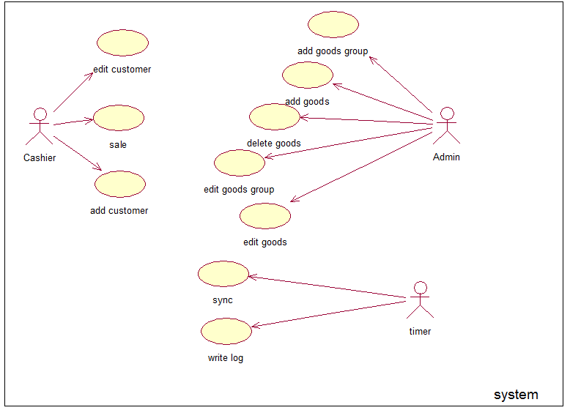

Usecase table.
Usecase ID | Name
UC01 | Add customer
UC02 | Edit customer
UC03 | Sale
UC04 | Add goods
UC05 | Edit goods
UC06 | Delete goods
UC07 | Add goods group
UC08 | Edit goods group
UC09 | Sync
UC10 | Write log

Use-Case ID:UC01 | Use-Case Name: add customer
Actor: cashier
Description: | Support actor to add customer information in system.
Preconditions: | Customer ID not have in system.
Primary Pathway: | - Actor fill customer information in form.  - Click “ok”.  - Program will check information.  - Sent new customer to server.  - Shop server check new customer information.  - Store into shop server database and send to main server.  - Main server sync new information between the others shop server.
Alternative Pathways:
Exception Pathways:
Includes
Extends | None

Use-Case ID:UC02 | Use-Case Name:
Actor:
Description:
Preconditions:
Primary Pathway:
Alternative Pathways:
Exception Pathways:
Includes
Extends | None

Use-Case ID:UC03 | Use-Case Name:
Actor:
Description:
Preconditions:
Primary Pathway:
Alternative Pathways:
Exception Pathways:
Includes
Extends | None

Use-Case ID:UC04 | Use-Case Name:
Actor:
Description:
Preconditions:
Primary Pathway:
Alternative Pathways:
Exception Pathways:
Includes
Extends | None

Use-Case ID:UC05 | Use-Case Name:
Actor:
Description:
Preconditions:
Primary Pathway:
Alternative Pathways:
Exception Pathways:
Includes
Extends | None

Use-Case ID:UC06 | Use-Case Name:
Actor:
Description:
Preconditions:
Primary Pathway:
Alternative Pathways:
Exception Pathways:
Includes
Extends | None

Use-Case ID:UC07 | Use-Case Name:
Actor:
Description:
Preconditions:
Primary Pathway:
Alternative Pathways:
Exception Pathways:
Includes
Extends | None

Use-Case ID:UC08 | Use-Case Name:
Actor:
Description:
Preconditions:
Primary Pathway:
Alternative Pathways:
Exception Pathways:
Includes
Extends | None

Use-Case ID:UC09 | Use-Case Name:
Actor:
Description:
Preconditions:
Primary Pathway:
Alternative Pathways:
Exception Pathways:
Includes
Extends | None

Use-Case ID:UC10 | Use-Case Name:
Actor:
Description:
Preconditions:
Primary Pathway:
Alternative Pathways:
Exception Pathways:
Includes
Extends | None

- Milestone.
Milestones | Date | Description
Begin |  | Start project, planning and prepare.
Requirement |  | Finish requirement, finish URD.
Design |  | Finish design document.
Coding |  | Complete product.
Testing |  | Ensure product has no defect release demo version.
End |  | Install and deploy to customer.

- Project tracking control.
How do you control your project ?
- Risk management (wide picture)
Top 10 risks in current project.
No | Risk | Priority | Type
1 | People’s assignments do not match their strengths. | High | Human resource.
2 | Lack member | High | Human resource.
3 | Low effort | High | Human resource.
4 | Lack of skill | High | Human resource.
5 | Limit of knowledge | High | Human resource.
6 | Not meet customer’s requirements. | High | Requirement
7 | Requirement change | High | Requirement
8 | Wrong estimate | Medium | Estimate
9 | Customer communication | Medium | Customer
10 | Customer don’t know what do they want ?

